Submitted by Zwe Min Oo

iNet



**User manual for admin side**

Student registration and enrollment system

Contents

User manual for admin side 2

How to login 2

Using menu bar 2

Changing view 4

Guide for course view 4

Guide for class view 5

Guide for student view 6

Guide for payment view 7

Figure 1 : How to login 2

Figure 2 : Using menu bar 3

Figure 3 : Changing view 4

Figure 4 : Guide for course view 4

Figure 5 : Guide for class view 5

Figure 6 : Guide for student view 6

Figure 7 : Guide for payment view 7

## User manual for admin side

### How to login

You need to fill username and password field to login. You can clear all field by clicking cancel button.

Note - Username are hard-coded.

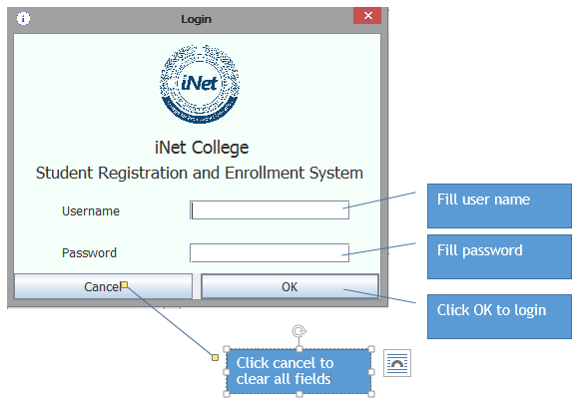

Figure 1 : How to login

### Using menu bar

You can use the menu bar easily.

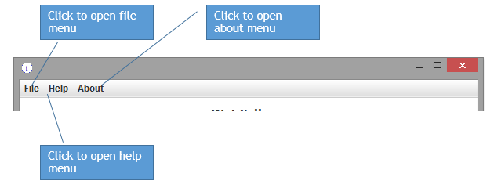

Figure 2 : Using menu bar

### Changing view

You can change the view by title that you want to change.

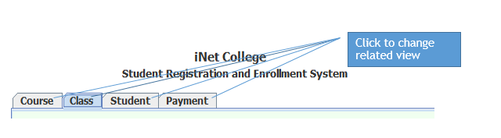

Figure 3 : Changing view

### Guide for course view

You can create, edit and deleting courses in course view.

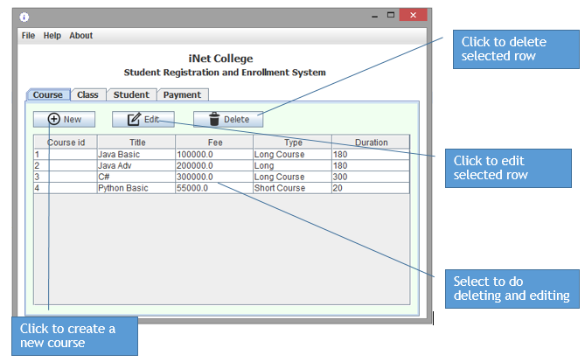

Figure 4 : Guide for course view

### Guide for class view

You can create, edit and delete classes in class view.

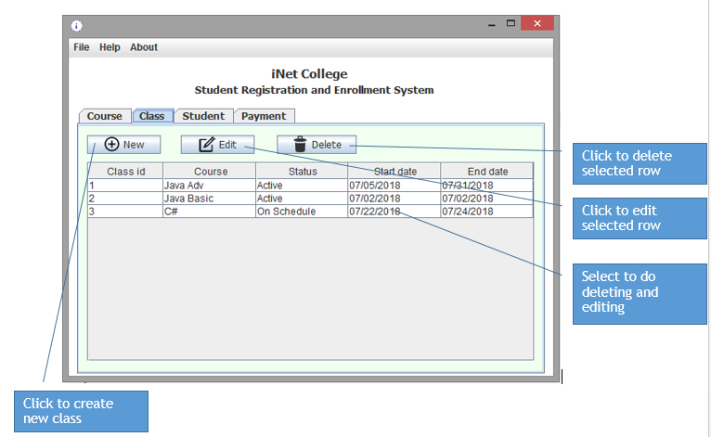

Figure 5 : Guide for class view

### Guide for student view

You can view the registered students’ information and search than by name.

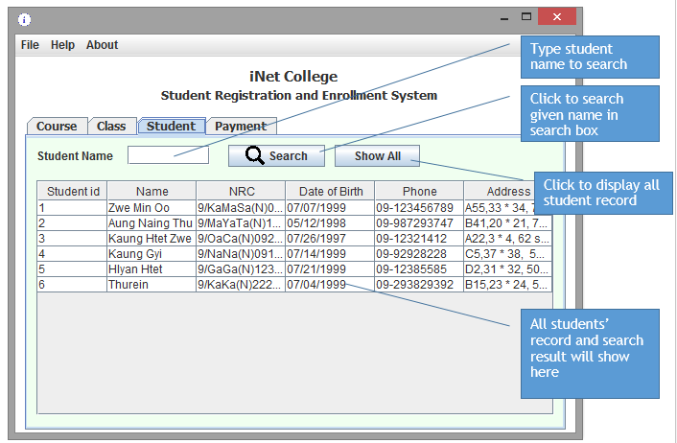

Figure 6 : Guide for student view

### Guide for payment view

You can view the payments by students for classes. But you can’t modify the payments.

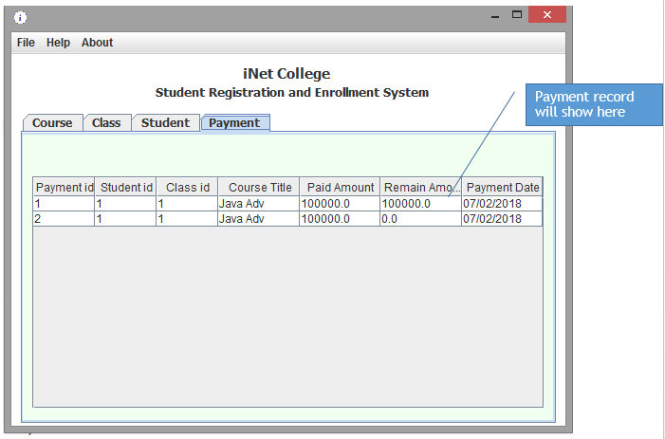

Figure 7 : Guide for payment view